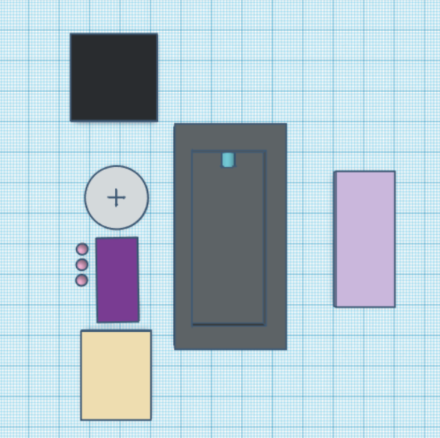

Explanation of the 3D Model of the watch

Black: OLED Screen 27.3 x 27.3 x 1 mm

Gray Circle: Battery 19.99 x 19.99 mm

Dark Purple: Bluetooth Module 26.9 x 13 x 2.2 mm

Light Purple: Arduino Nano 43.18 x 18.54 x 2 mm

Crème: RTC Module 28 x 22 x 1 mm

Gray Square: Watch Holder

Pink Circles: Mechanical Buttons

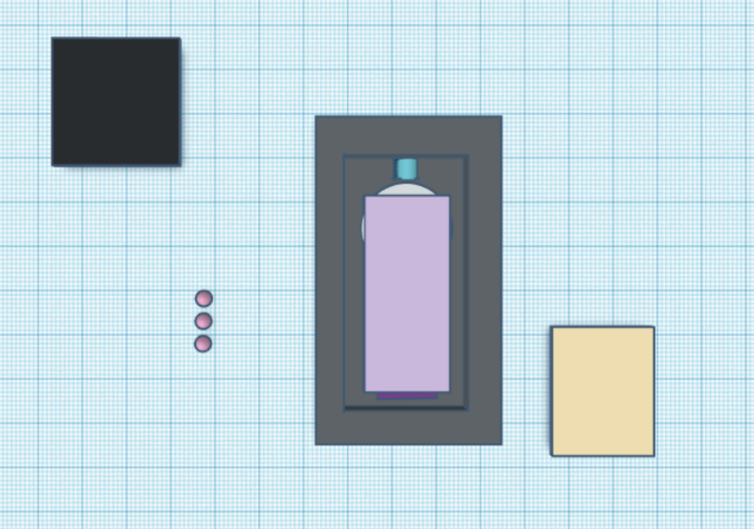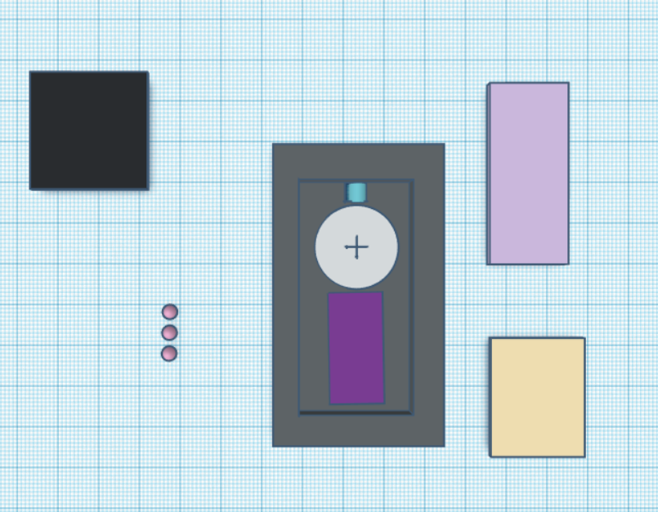

Order of assembly inside case

1. Bluetooth module, battery, and temp sensor will go first
2. The Arduino nano will go in next
3. The OLED screen and RTC module will go on top. The buttons will go next to the RTC module

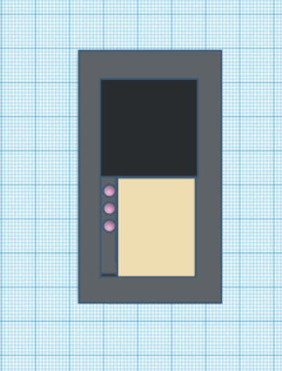

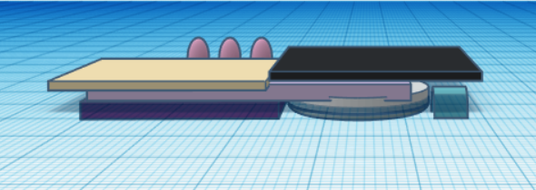

Side view of assembly

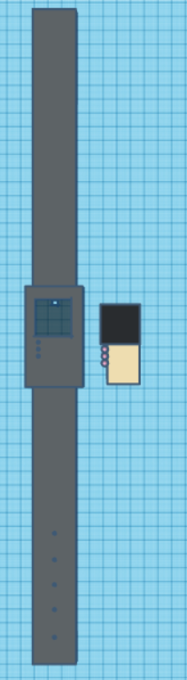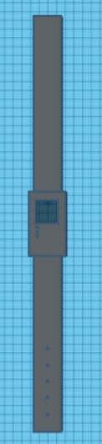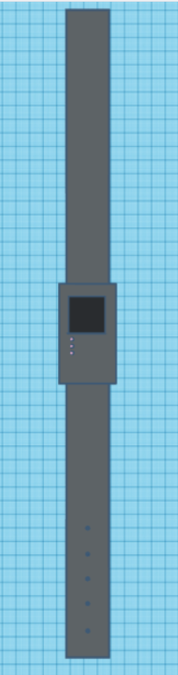

There is a hole in the case in which the temperature sensor will go through to get contact with skin. You can see the hole more clearly in the second image here, it’s a little dot

Completed watch

Watch case next to assembly

Empty watch case, including the watch band